**Sequence diagram:**

If the lifeline is that of an object, it demonstrates a role. Leaving the instance name blank can represent anonymous and unnamed instances.

Messages, written with horizontal [arrows](https://en.wikipedia.org/wiki/Arrow_(symbol)) with the message name written above them, display interaction. Solid arrow heads represent synchronous calls, open arrow heads represent asynchronous messages, and dashed lines represent reply messages. If a caller sends a synchronous message, it must wait until the message is done, such as invoking a subroutine. If a caller sends an asynchronous message, it can continue processing and doesn’t have to wait for a response. Asynchronous calls are present in multithreaded applications and in [message-oriented middleware](https://en.wikipedia.org/wiki/Message-oriented_middleware). Activation boxes, or method-call boxes, are opaque rectangles drawn on top of lifelines to represent that processes are being performed in response to the message (Execution Specifications in UML).

Objects calling methods on themselves use messages and add new activation boxes on top of any others to indicate a further level of [processing](https://en.wikipedia.org/wiki/Process_(computing)).

When an object is [destroyed](https://en.wikipedia.org/wiki/Object_lifetime) (removed from [memory](https://en.wikipedia.org/wiki/Computer_storage)), an X is drawn on top of the lifeline, and the dashed line ceases to be drawn below it (this is not the case in the first example though). It should be the result of a message, either from the object itself, or another.

A message sent from outside the diagram can be represented by a message originating from a filled-in circle (found message in UML) or from a border of the sequence diagram (gate in UML).

UML has introduced significant improvements to the capabilities of sequence diagrams. Most of these improvements are based on the idea of interaction fragments which represent smaller pieces of an enclosing interaction. Multiple interaction fragments are combined to create a variety of combined fragments,which are then used to model interactions that include parallelism, conditional branches, optional interactions.

When an object is [destroyed](https://en.wikipedia.org/wiki/Object_lifetime) (removed from [memory](https://en.wikipedia.org/wiki/Computer_storage)), an X is drawn on top of the lifeline, and the dashed line ceases to be drawn below it (this is not the case in the first example though). It should be the result of a message, either from the object itself, or another. A message sent from outside the diagram can be represented by a message originating from a filled-in circle (found message in UML) or from a border of the sequence diagram (gate in UML).

**Login:**

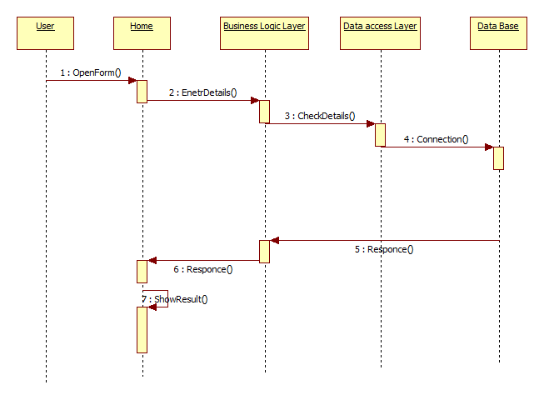

**Registration:**

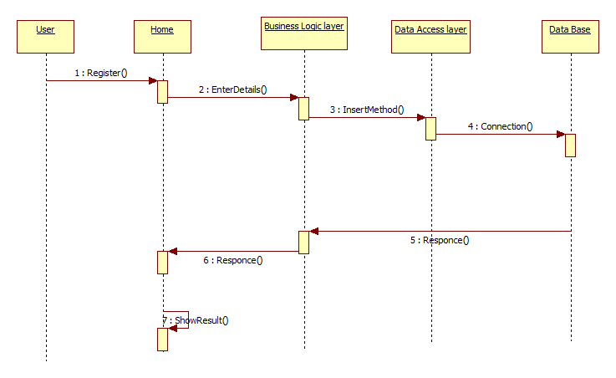

**Importdataset sequence diagram**

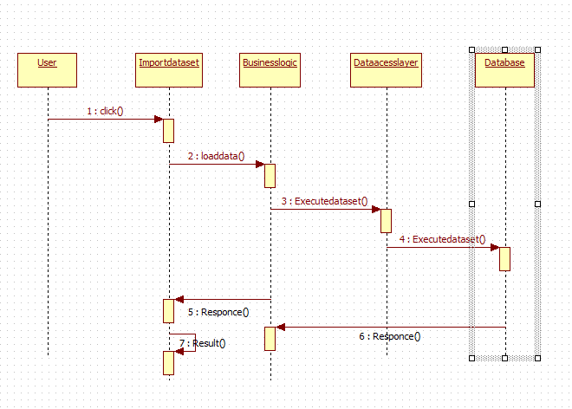

**Data paritioning**

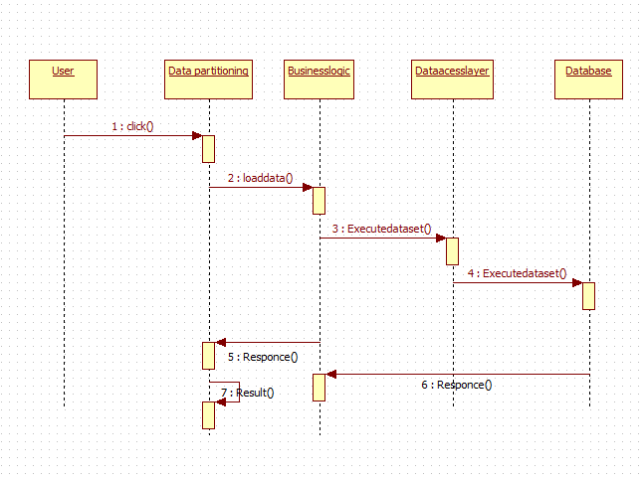

**IPOLHS**

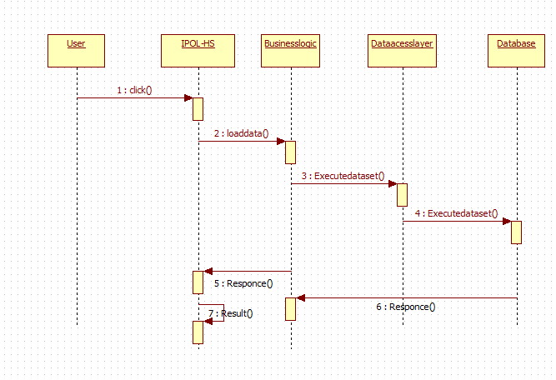

**REGIONS**

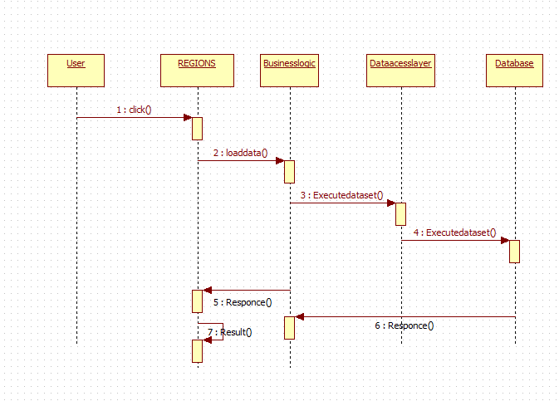

**GROUPS**

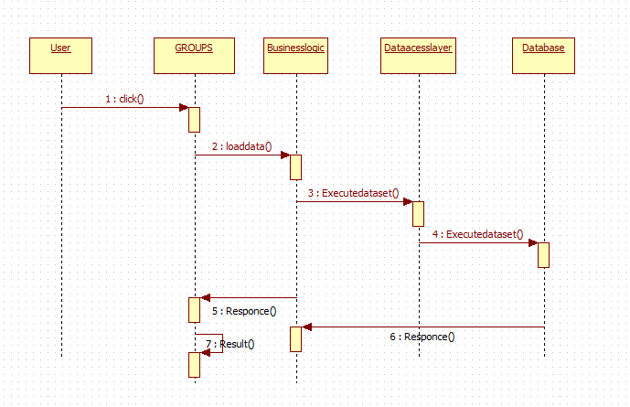

UPDATE PROFILE

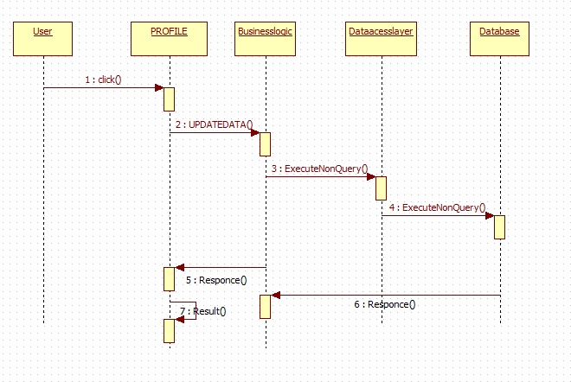

SEARCH SEQUENCE DIAGRAM

